DOCKER_CHALLENGE
TASKS:
Create a customized Docker image using a Dockerfile.
Push the image to Docker Hub.
Push the same image to Amazon ECR.
Provision one EC2 instance using Terraform and install Jenkins.
Create one Jenkins job to build and push the Docker image to Docker Hub.
1. Source: https://github.com/betawins/Python-app.git
Source Codes: https://github.com/betawins/docker-tasks.git
From the frontend source code, write a Dockerfile, build a Docker image, run
it, and push that image to your Docker registry.
From the Java-based source code, write a Dockerfile, build, run, and push the
image to the Docker registry.
From the Node.js-based source code, write a Dockerfile, build with tag v1,
run, and push it to the Docker registry.
• Write a docker-compose file to set up WordPress with a MySQL
database.
1. Create a customized Docker image using a Dockerfile. Push the image to Docker Hub. Push the same image to Amazon ECR.
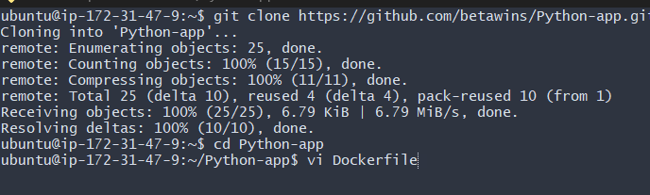
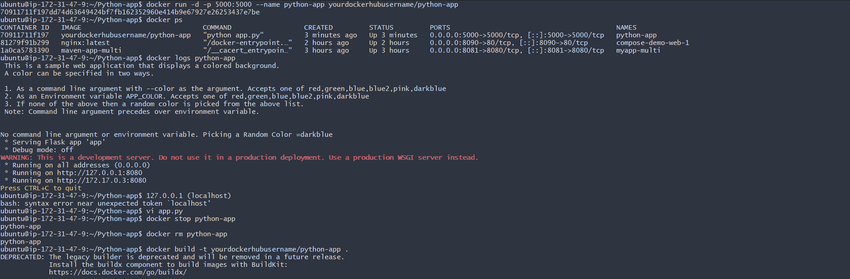
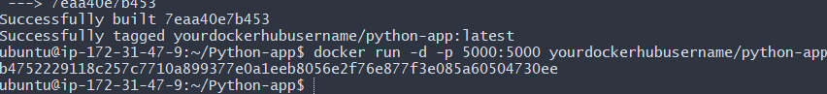
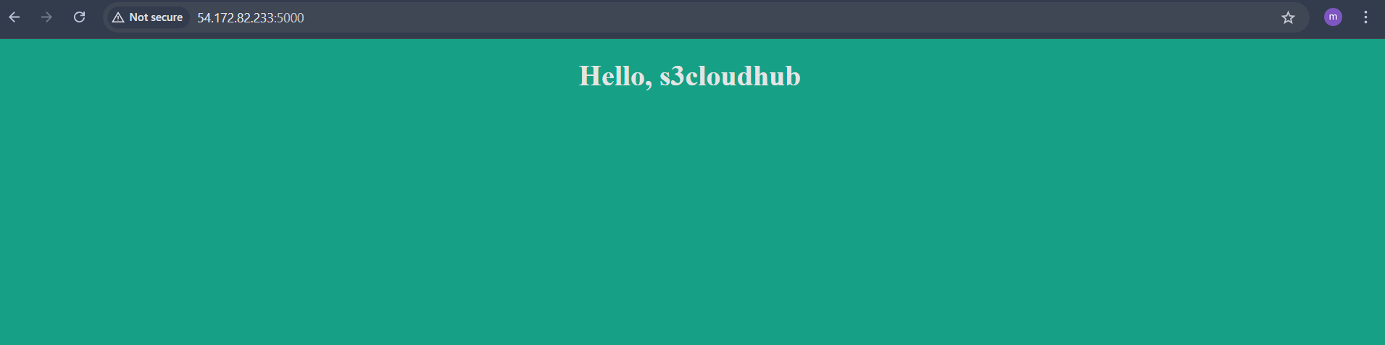
2. Push Image to Docker Hub
Step 1: Login to Docker Hub docker loginStep 2: Tag the image
Docker Hub format:
<dockerhub-username>/<image-name>:<tag>
docker tag my-custom-app:1.0 arjumand10/my-custom-app:1.0
Step 3: Push the image
docker push arjumand10/my-custom-app:1.0
Image is now available on Docker Hub
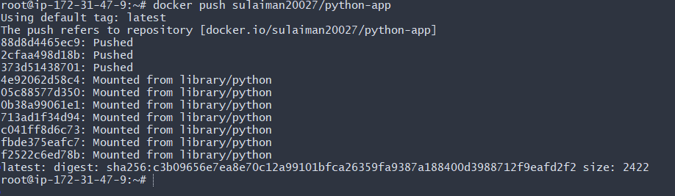
Verified with docker repo

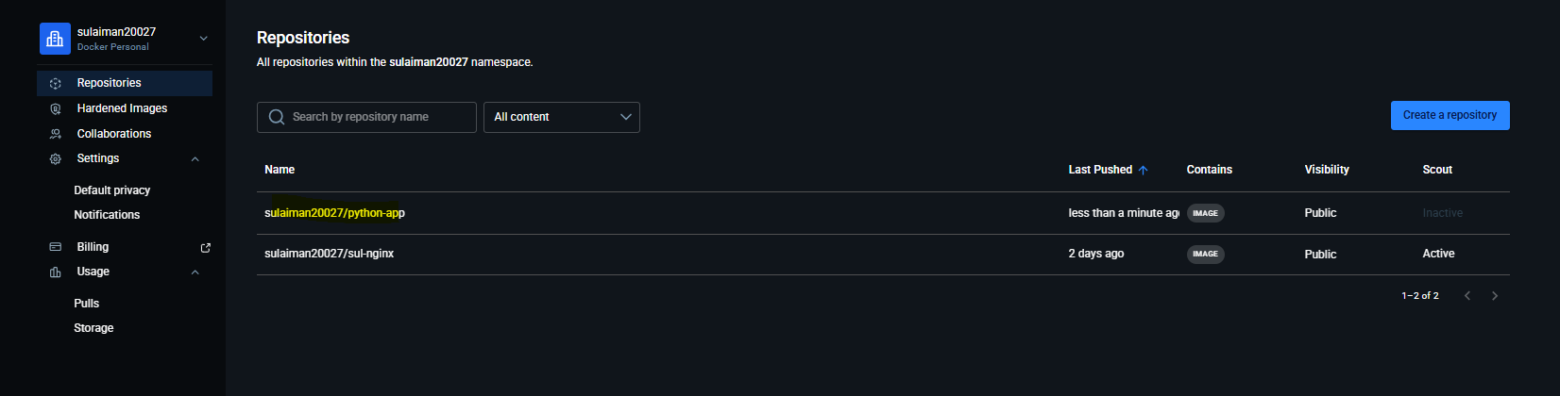
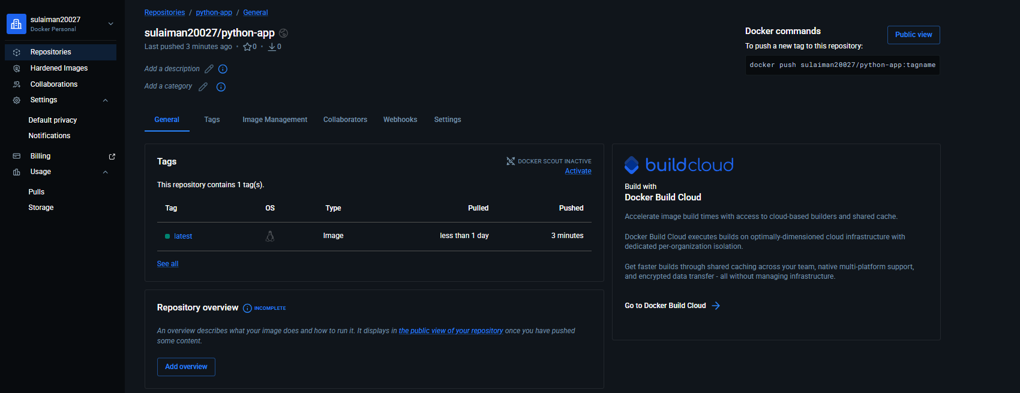
3. Push the Same Image to Amazon ECR
Prerequisites
• AWS account
• AWS CLI configured:
aws configure
• IAM permissions for ECR
Configure AWS
aws configure
👉 Enter:
AWS Access Key ID: <your-access-key>
AWS Secret Access Key: <your-secret-key>
Default region name: ap-south-1
Default output format: json

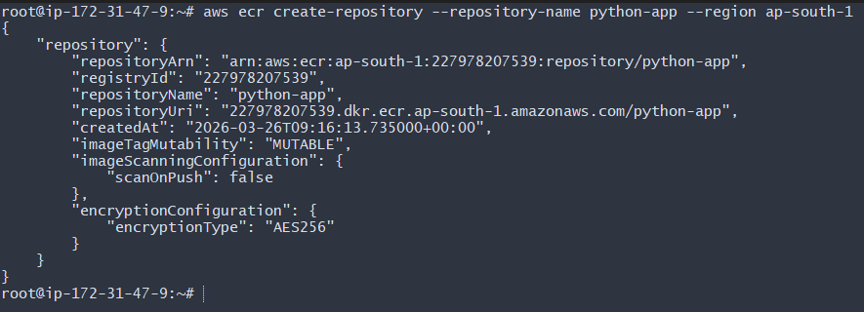
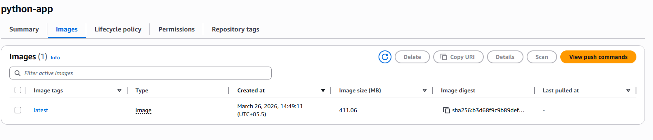
2. Provision one EC2 instance using Terraform and install Jenkins.
Provision EC2 with Terraform + Install Jenkins
Run Terraform Commands
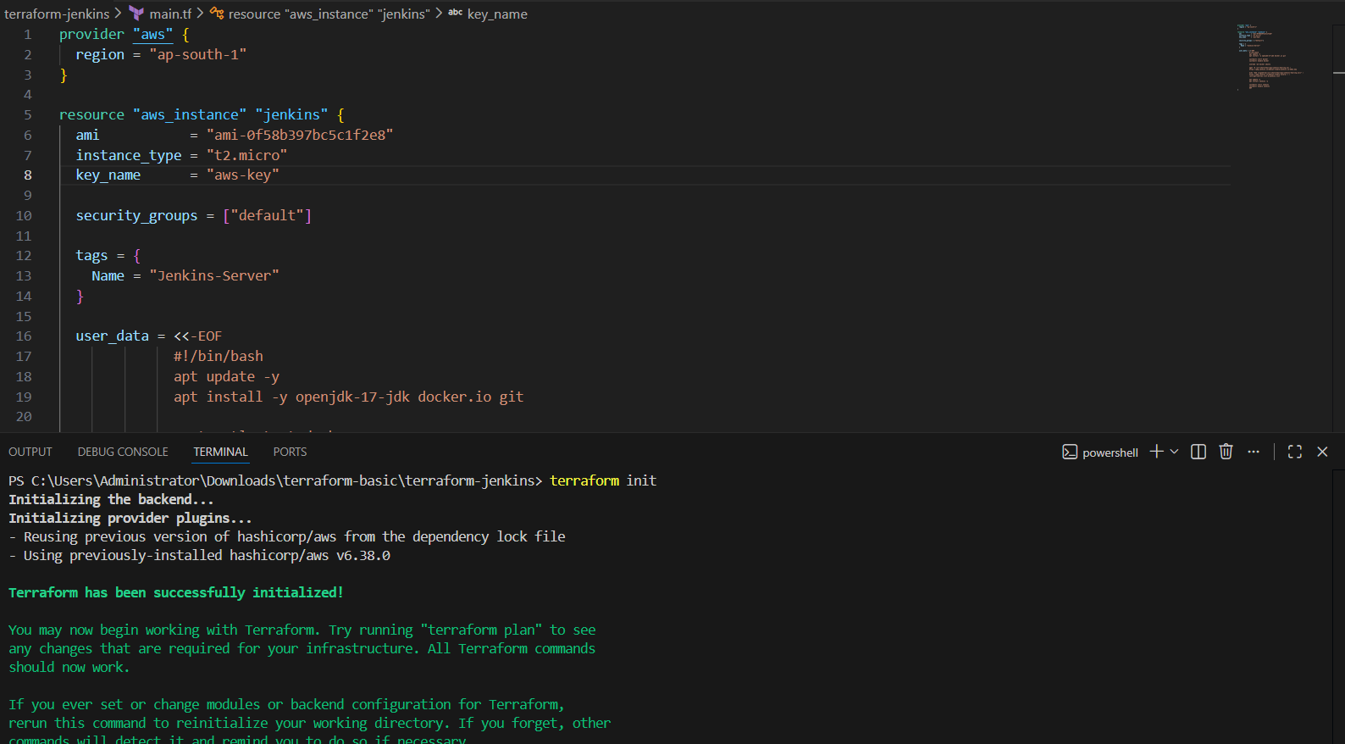
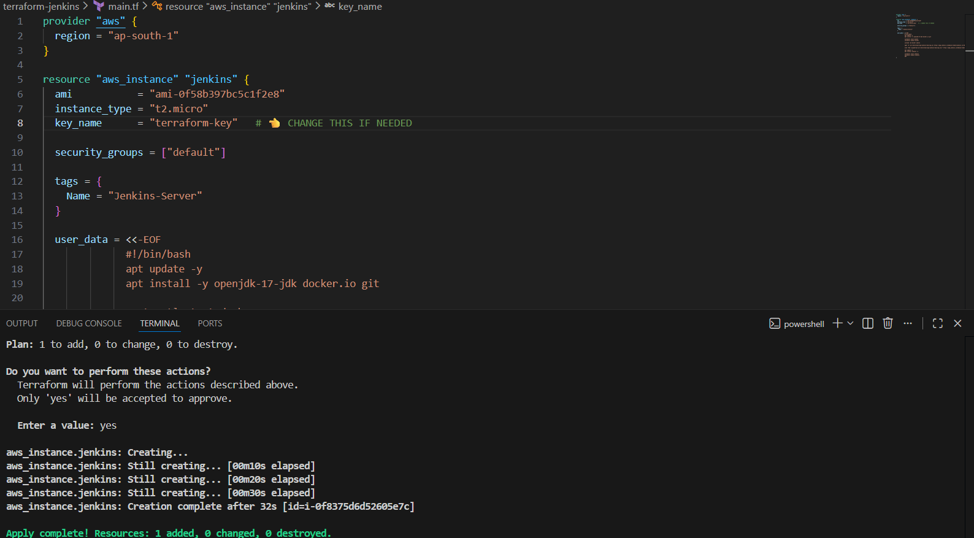
→Validation: One Jenkins server ec2 has been created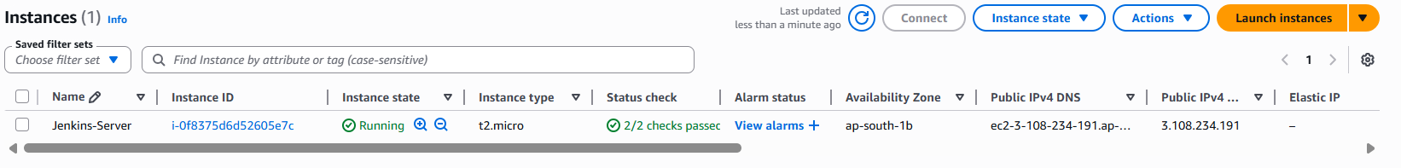
Jenkins Access After Terraform completes, copy EC2 Public IP and open:
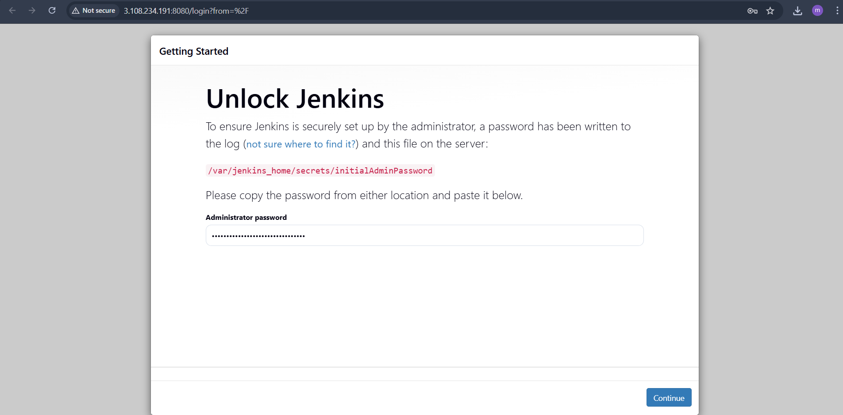
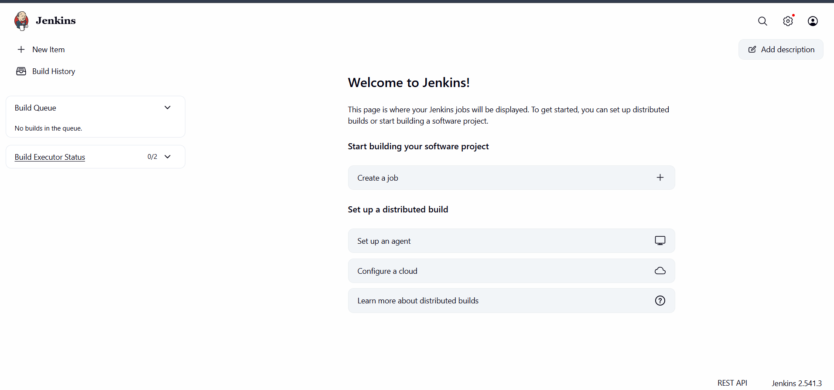
Jenkins Pipeline Job (Build + Push DockerHub)
Jenkins Plugins Install
Go to:
Manage Jenkins → Plugins
Install:
Docker Pipeline
Git Plugin
Credentials Binding
Add DockerHub Credentials
Manage Jenkins → Credentials → Global → Add Credentials
• Type: Username with password
• ID: dockerhub-creds
• Username: DockerHub username
• Password: DockerHub password
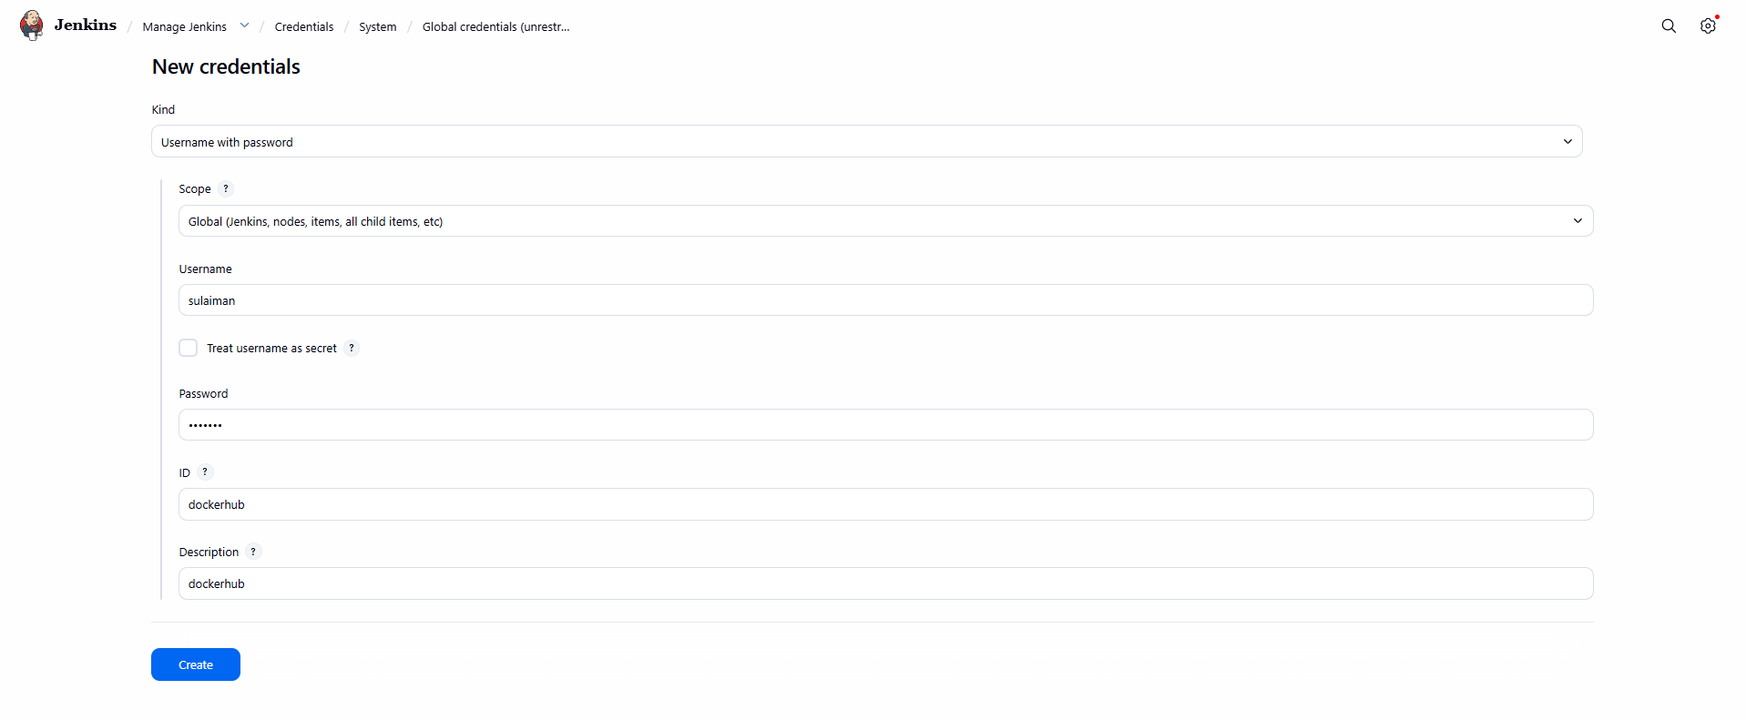
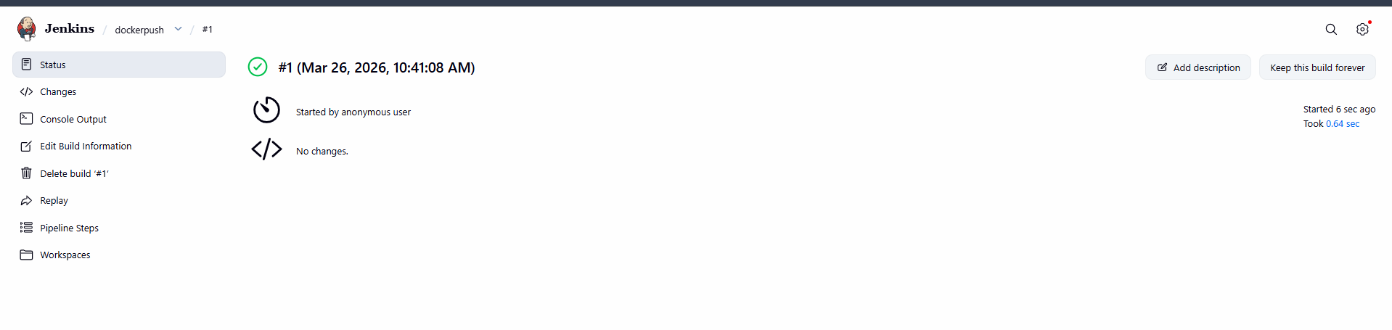
3. Source Codes: https://github.com/betawins/docker-tasks.git
From the frontend source code, write a Dockerfile, build a Docker
image, run it, and push that image to your Docker registry.
STEP: Clone docker-tasks Repo
git clone https://github.com/betawins/docker-tasks.git
cd docker-tasks
Clone docker-tasks Repo
git clone https://github.com/betawins/docker-tasks.git
cd docker-tasks
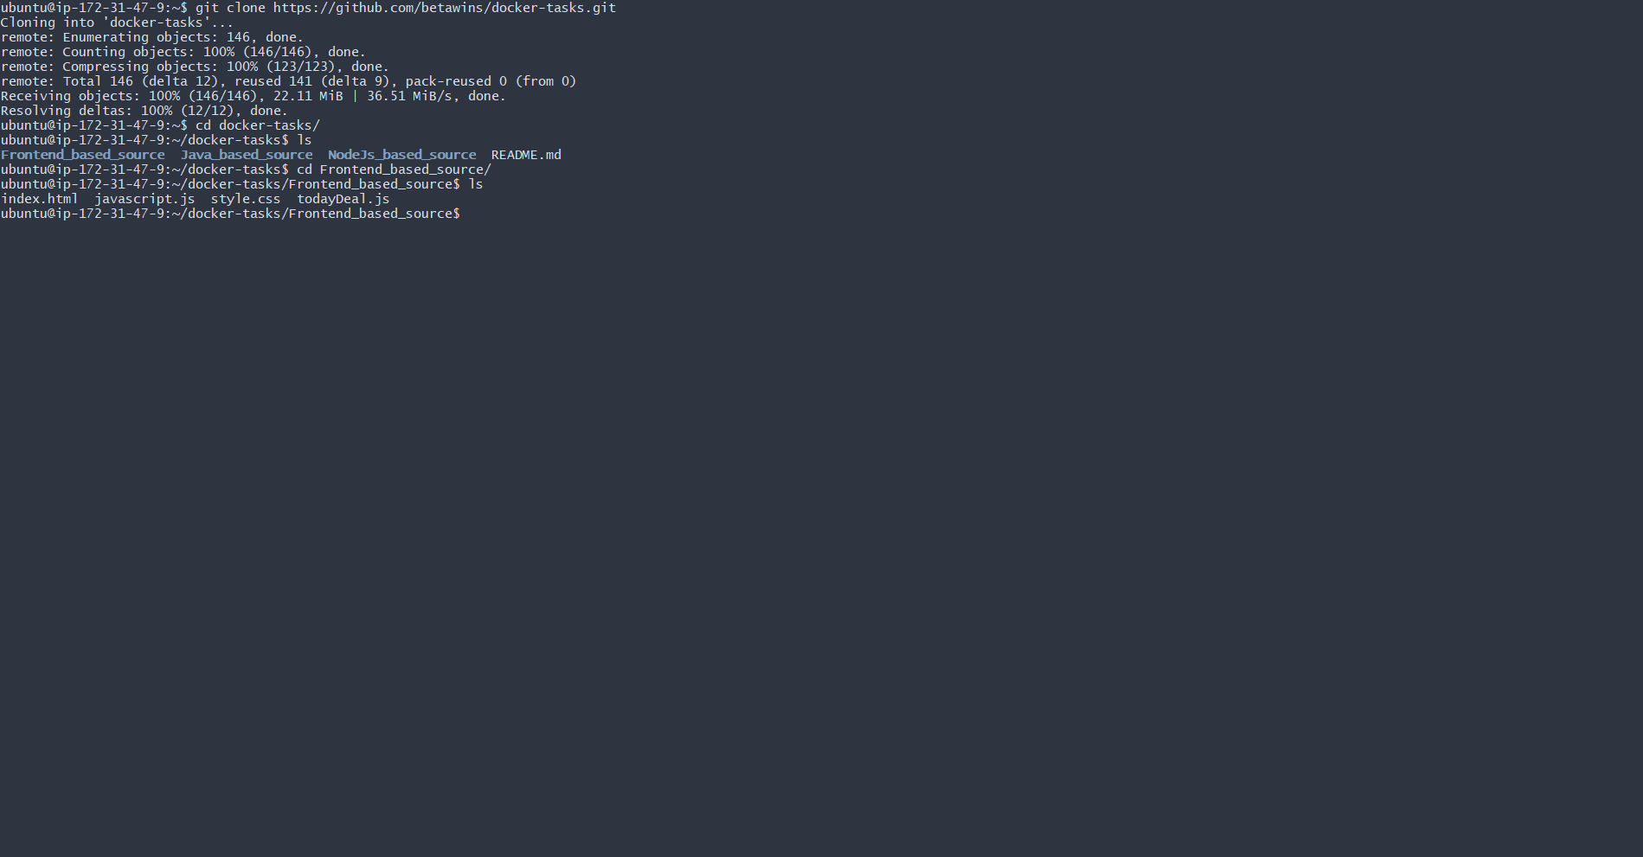
STEP 11: Frontend Dockerfile (React)
Go to frontend folder (example):
cd frontend
Create Dockerfile
# Base image
FROM nginx:latest
# Maintainer name
LABEL maintainer="Sulaiman"
# Remove default nginx content
RUN rm -rf /usr/share/nginx/html/*
# Copy custom index.html
COPY index.html /usr/share/nginx/html/index.html
# Expose port 80
EXPOSE 80
# Start nginx
CMD ["nginx", "-g", "daemon off;"]
5#. Expose on port 80
EXPOSE 80
EXPOSE 80
CMD ["nginx", "-g", "daemon off;"
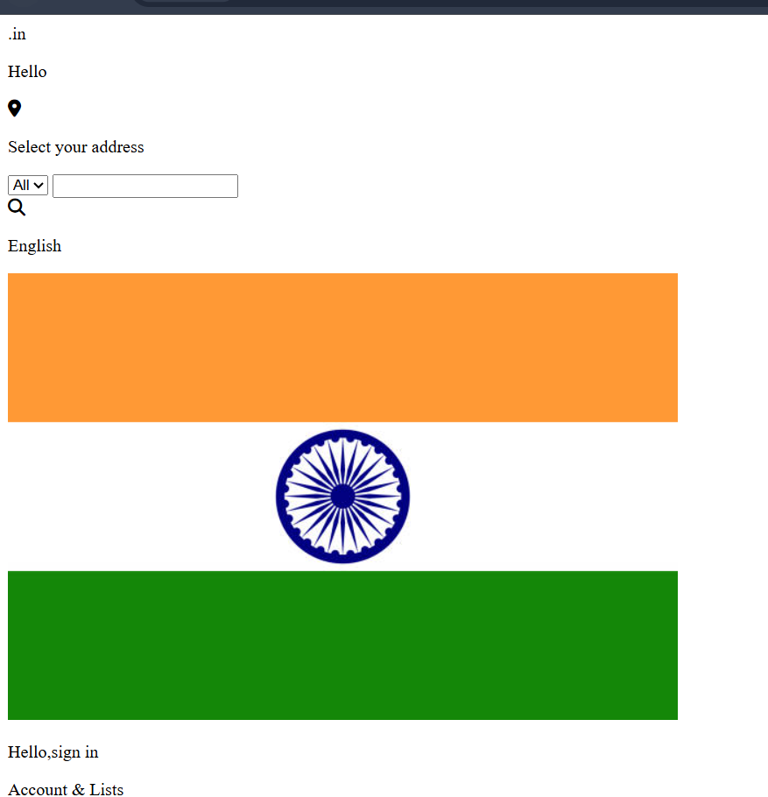
4. From the Java-based source code, write a Dockerfile, build, run, and
push the image to the Docker registry.
Java Dockerfile
Go to Java folder:
cd java-app
Create Dockerfile
FROM maven:3.9.6-eclipse-temurin-17 AS build
WORKDIR /app
COPY . .
RUN mvn clean package -DskipTests
FROM eclipse-temurin:17-jdk-alpine
WORKDIR /app
COPY --from=build /app/target/*.jar app.jar
EXPOSE 8080
CMD ["java", "-jar", "app.jar"]
Push DockerHub docker tag java-app:v1 /java-app:v1 docker push /java-app:v1

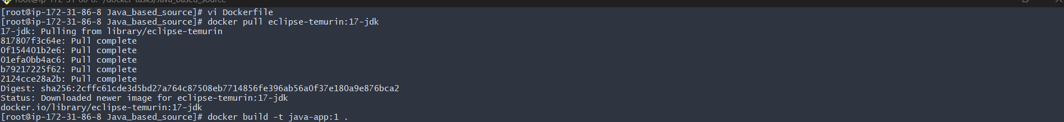

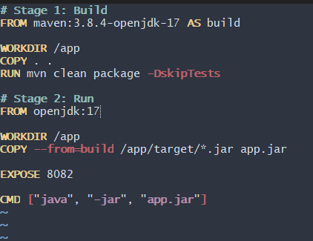
Run docker run -itd --name java_container -p 8082:8080 java-app:v1
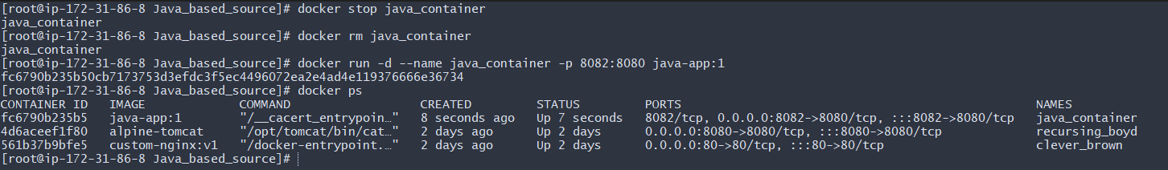
validation on the web using port number 8082

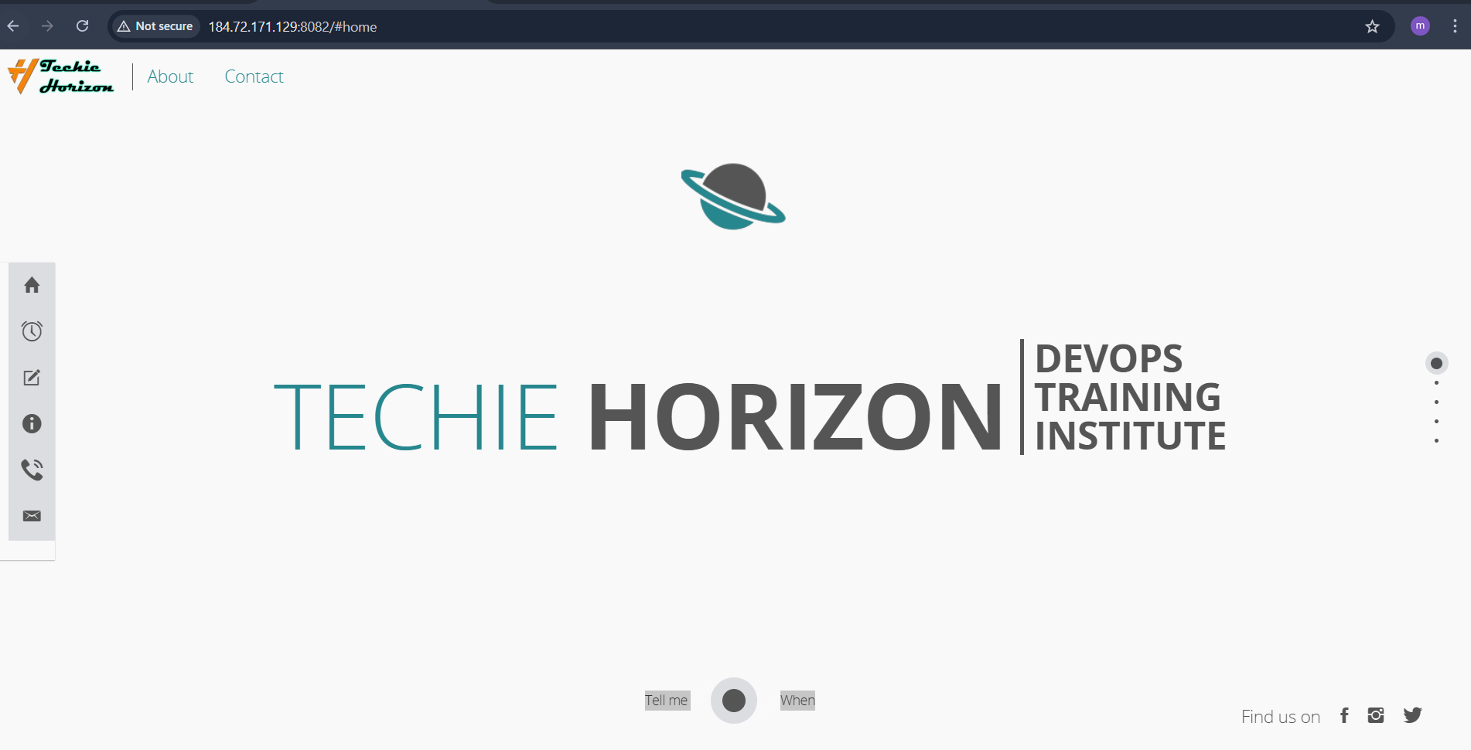
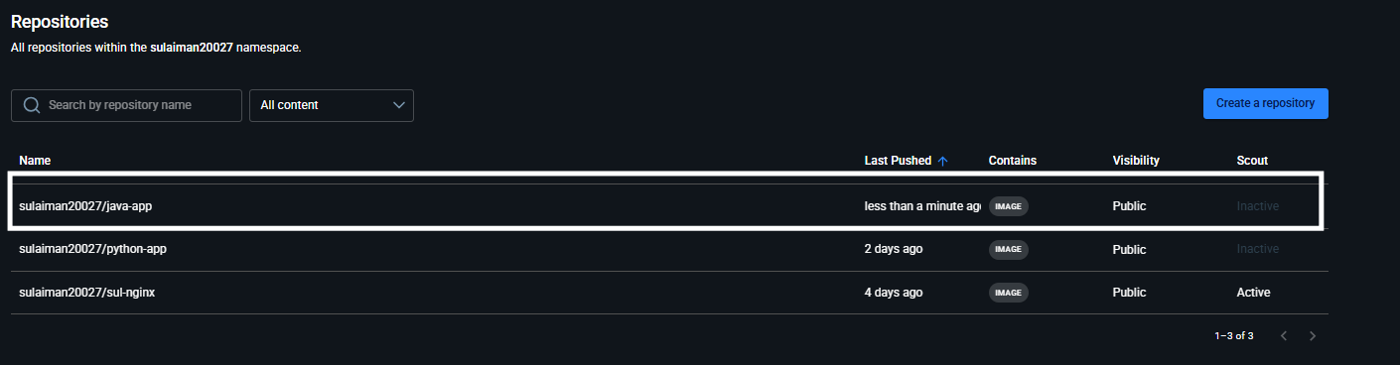
5. From the Node.js-based source code, write a Dockerfile, build with tag v1, run, and push it to the Docker registry
Run docker run -d -p 3000:3000 node1-app:v1 Push DockerHub docker tag node1-app:v1 /node-app:v1 docker push /node1-app:v1
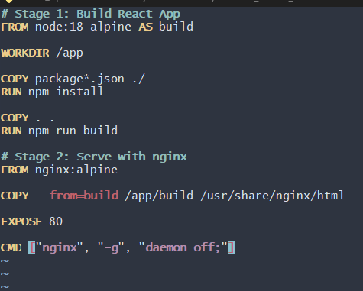

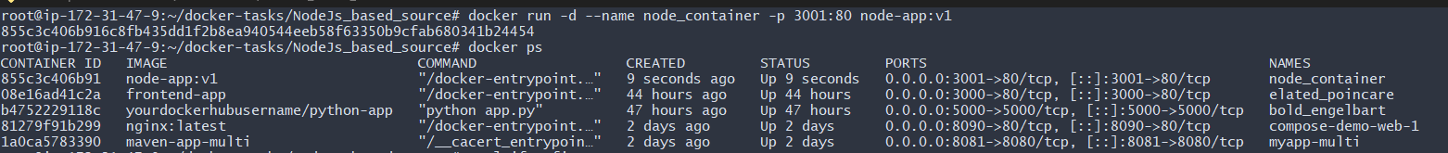
→Validation:


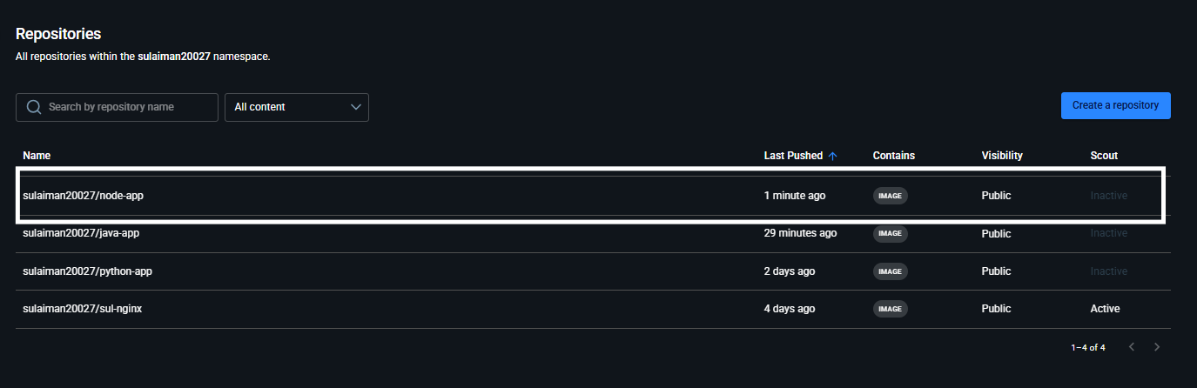
6. Write a docker-compose file to set up WordPress with a MySQL database.
First check docker compose is install or not in my case already install it so it showing version
Next create word repo wordpress docker then go inside then vi paste script then run it
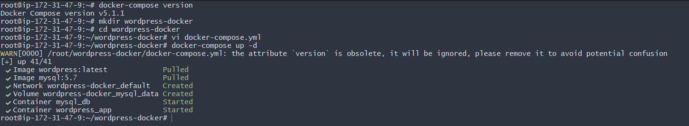

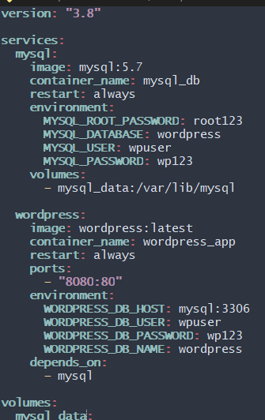
Now lets go url verfy its working successfully on port 8080
